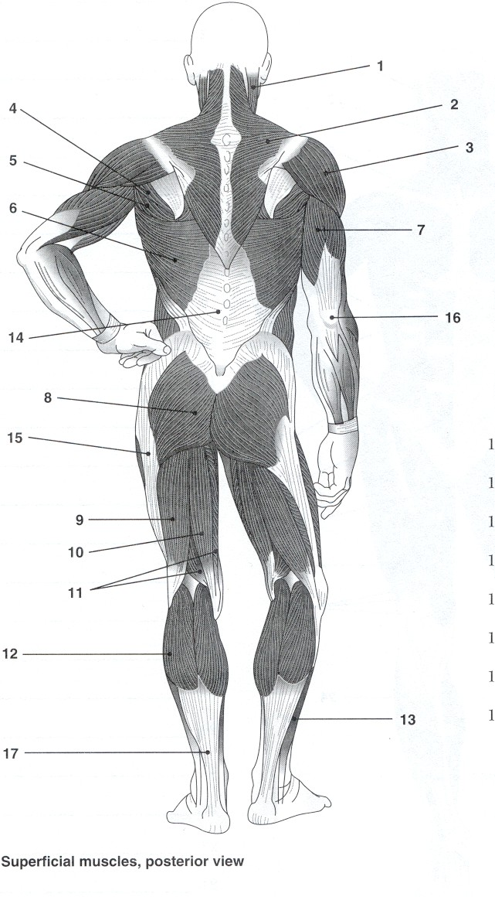**Muscles- Posterior View**

1. Deltoid
2. Hamstrings
3. Tricep
4. Latissimus dorsi
5. Gastrocnemius
6. Gluteus Maximus
7. Achilles Tendon
8. Trapezius